不确定性推理参考答案

6.8 设有如下一组推理规则:
r₁: IF E₁ THEN E₂ (0.6)
r₂: IF E₂ AND E₃ THEN E₄ (0.7)
r₃: IF E₄ THEN H (0.8)
r₄: IF E₅ THEN H (0.9)
且已知CF(E₁)=0.5, CF(E₃)=0.6, CF(E₅)=0.7。求CF(H)=?
解：(1) 先由r₁求CF(E₂)
CF(E₂)=0.6 × max{0,CF(E₁)}
=0.6 × max{0,0.5}=0.3
(2) 再由r₂求CF(E₄)
CF(E₄)=0.7 × max{0, min{CF(E₂ ), CF(E₃ )}}
=0.7 × max{0, min{0.3, 0.6}}=0.21
(3) 再由r₃求CF₁(H)
CF₁(H)= 0.8 × max{0,CF(E₄)}
=0.8 × max{0, 0.21)}=0.168
(4) 再由r₄求CF₂(H)
CF₂(H)= 0.9 ×max{0,CF(E₅)}
=0.9 ×max{0, 0.7)}=0.63
(5) 最后对CF₁(H )和CF₂(H)进行合成，求出CF(H)
CF(H)= CF₁(H)+CF₂(H)+ CF₁(H) × CF₂(H)
=0.692

6.10 设有如下推理规则
r₁: IF E₁ THEN (2, 0.00001) H₁
r₂: IF E₂ THEN (100, 0.0001) H₁
r₃: IF E₃ THEN (200, 0.001) H₂
r₄: IF H₁ THEN (50, 0.1) H₂
且已知P(E₁)= P(E₂)= P(H₃)=0.6, P(H₁)=0.091, P(H₂)=0.01, 又由用户告知：
P(E₁| S₁)=0.84, P(E₂|S₂)=0.68, P(E₃|S₃)=0.36
请用主观Bayes方法求P(H₂|S₁, S₂, S₃)=?
解：(1) 由r₁计算O(H₁| S₁)
先把H₁的先验概率更新为在E₁下的后验概率P(H₁| E₁)
P(H₁| E₁)=(LS₁ × P(H₁)) / ((LS₁-1) × P(H₁)+1)
=(2 × 0.091) / ((2 -1) × 0.091 +1)
=0.16682
由于P(E₁|S₁)=0.84 > P(E₁)，使用P(H | S)公式的后半部分，得到在当前观察S₁下的后验概率P(H₁| S₁)和后验几率O(H₁| S₁)
P(H₁| S₁) = P(H₁) + ((P(H₁| E₁) – P(H₁)) / (1 - P(E₁))) × (P(E₁| S₁) – P(E₁))
= 0.091 + (0.16682 –0.091) / (1 – 0.6)) × (0.84 – 0.6)
=0.091 + 0.18955 × 0.24 = 0.136492
O(H₁| S₁) = P(H₁| S₁) / (1 - P(H₁| S₁))
= 0.15807
(2) 由r₂计算O(H₁| S₂)
先把H₁的先验概率更新为在E₂下的后验概率P(H₁| E₂)
P(H₁| E₂)=(LS₂ × P(H₁)) / ((LS₂-1) × P(H₁)+1)
=(100 × 0.091) / ((100 -1) × 0.091 +1)
=0.90918
由于P(E₂|S₂)=0.68 > P(E₂)，使用P(H | S)公式的后半部分，得到在当前观察S₂下的后验概率P(H₁| S₂)和后验几率O(H₁| S₂)
P(H₁| S₂) = P(H₁) + ((P(H₁| E₂) – P(H₁)) / (1 - P(E₂))) × (P(E₂| S₂) – P(E₂))
= 0.091 + (0.90918 –0.091) / (1 – 0.6)) × (0.68 – 0.6)
=0.25464
O(H₁| S₂) = P(H₁| S₂) / (1 - P(H₁| S₂))
=0.34163
(3) 计算O(H₁| S₁,S₂)和P(H₁| S₁,S₂)
先将H₁的先验概率转换为先验几率
O(H₁) = P(H₁) / (1 - P(H₁)) = 0.091/(1-0.091)=0.10011
再根据合成公式计算H₁的后验几率
O(H₁| S₁,S₂)= (O(H₁| S₁) / O(H₁)) × (O(H₁| S₂) / O(H₁)) × O(H₁)
= (0.15807 / 0.10011) × (0.34163) / 0.10011) × 0.10011
= 0.53942
再将该后验几率转换为后验概率
P(H₁| S₁,S₂) = O(H₁| S₁,S₂) / (1+ O(H₁| S₁,S₂))
= 0.35040
(4) 由r₃计算O(H₂| S₃)
先把H₂的先验概率更新为在E₃下的后验概率P(H₂| E₃)
P(H₂| E₃)=(LS₃ × P(H₂)) / ((LS₃-1) × P(H₂)+1)
=(200 × 0.01) / ((200 -1) × 0.01 +1)
=0.09569
由于P(E₃|S₃)=0.36 < P(E₃)，使用P(H | S)公式的前半部分，得到在当前观察S₃下的后验概率P(H₂| S₃)和后验几率O(H₂| S₃)
P(H₂| S₃) = P(H₂ | ¬ E₃) + (P(H₂) – P(H₂| ¬E₃)) / P(E₃)) × P(E₃| S₃)
由当E₃肯定不存在时有
P(H₂ | ¬ E₃) = LN₃ × P(H₂) / ((LN₃-1) × P(H₂) +1)
= 0.001 × 0.01 / ((0.001 - 1) × 0.01 + 1)
= 0.00001
因此有
P(H₂| S₃) = P(H₂ | ¬ E₃) + (P(H₂) – P(H₂| ¬E₃)) / P(E₃)) × P(E₃| S₃)
=0.00001+((0.01-0.00001) / 0.6) × 0.36
=0.00600
O(H₂| S₃) = P(H₂| S₃) / (1 - P(H₂| S₃))
=0.00604
(5) 由r₄计算O(H₂| H₁)
先把H₂的先验概率更新为在H₁下的后验概率P(H₂| H₁)
P(H₂| H₁)=(LS₄ × P(H₂)) / ((LS₄-1) × P(H₂)+1)
=(50 × 0.01) / ((50 -1) × 0.01 +1)
=0.33557
由于P(H₁| S₁,S₂)=0.35040 > P(H₁)，使用P(H | S)公式的后半部分，得到在当前观察S₁,S₂下H₂的后验概率P(H₂| S₁,S₂)和后验几率O(H₂| S₁,S₂)
P(H₂| S₁,S₂) = P(H₂) + ((P(H₂| H₁) – P(H₂)) / (1 - P(H₁))) × (P(H₁| S₁,S₂) – P(H₁))
= 0.01 + (0.33557 –0.01) / (1 – 0.091)) × (0.35040 – 0.091)
=0.10291
O(H₂| S₁,S₂) = P(H₂| S₁, S₂) / (1 - P(H₂| S₁, S₂))
=0.10291/ (1 - 0.10291) = 0.11472
(6) 计算O(H₂| S₁,S₂,S₃)和P(H₂| S₁,S₂,S₃)
先将H₂的先验概率转换为先验几率
O(H₂) = P(H₂) / (1 - P(H₂) )= 0.01 / (1-0.01)=0.01010
再根据合成公式计算H₁的后验几率
O(H₂| S₁,S₂,S₃)= (O(H₂| S₁,S₂) / O(H₂)) × (O(H₂| S₃) / O(H₂)) ×O(H₂)
= (0.11472 / 0.01010) × (0.00604) / 0.01010) × 0.01010
=0.06832
再将该后验几率转换为后验概率
P(H₂| S₁,S₂,S₃) = O(H₁| S₁,S₂,S₃) / (1+ O(H₁| S₁,S₂,S₃))
= 0.06832 / (1+ 0.06832) = 0.06395
可见，H₂原来的概率是0.01，经过上述推理后得到的后验概率是0.06395，它相当于先验概率的6倍多。

6.11设有如下推理规则
r_{1:} IF E₁ THEN (100, 0.1) H₁
r₂: IF E₂ THEN (50, 0.5) H₂
r₃: IF E₃ THEN (5, 0.05) H₃
且已知P(H₁)=0.02, P(H₂)=0.2, P(H₃)=0.4，请计算当证据E₁，E₂，E₃存在或不存在时P(H_{i} | E_{i})或P(H_{i} |﹁E_{i})的值各是多少(i=1, 2, 3)？
解：(1) 当E₁、E₂、E₃肯定存在时，根据r₁、r₂、r₃有
P(H₁ | E₁) = (LS₁ × P(H₁)) / ((LS₁-1) × P(H₁)+1)
= (100 × 0.02) / ((100 -1) × 0.02 +1)
=0.671
P(H₂ | E₂) = (LS₂ × P(H₂)) / ((LS₂-1) × P(H₂)+1)
= (50 × 0.2) / ((50 -1) × 0.2 +1)
=0.9921
P(H₃ | E₃) = (LS₃ × P(H₃)) / ((LS₃-1) × P(H₃)+1)
= (5 × 0.4) / ((5 -1) × 0.4 +1)
=0.769
(2) 当E₁、E₂、E₃肯定存在时，根据r₁、r₂、r₃有
P(H₁ | ¬E₁) = (LN₁ × P(H₁)) / ((LN₁-1) × P(H₁)+1)
= (0.1 × 0.02) / ((0.1 -1) × 0.02 +1)
=0.002
P(H₂ | ¬E₂) = (LN₂ × P(H₂)) / ((LN₂-1) × P(H₂)+1)
= (0.5 × 0.2) / ((0.5 -1) × 0.2 +1)
=0.111
P(H₃ | ¬E₃) = (LN₃ × P(H₃)) / ((LN₃-1) × P(H₃)+1)
= (0.05 × 0.4) / ((0.05 -1) × 0.4 +1)
=0.032

6.13 设有如下一组推理规则:
r1: IF E₁ AND E₂ THEN A={a} (CF={0.9})
r2: IF E₂ AND (E₃ OR E₄) THEN B={b₁, b₂} (CF={0.5, 0.4})
r3: IF A THEN H={h₁, h₂, h₃} (CF={0.2, 0.3, 0.4})
r4: IF B THEN H={h₁, h₂, h₃} (CF={0.3, 0.2, 0.1})
且已知初始证据的确定性分别为：
CER(E₁)=0.6, CER(E₂)=0.7, CER(E₃)=0.8, CER(E₄)=0.9。
假设|Ω|=10，求CER(H)？
解：其推理过程如下图所示，其步骤如下：
H
A
B
E₁
E₂
E₂
E₃
E₄
习题6.13的推理网络
(1) 求CER(A)

∵ CER(E₁ AND E₂₎
=min{CER(E₁), CER(E₂)}
=min{0.6, 0.7}
=0.6
m({a})={0.6×0.9}
=0.54
Bel(A)=m({a})=0.54
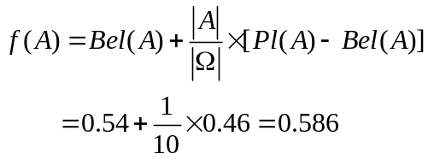 Pl(A)=1-Bel(﹁A)=1-0=1
∴ CER(A)=MD(A/E')×f(A)=0.586

(2) 求CER(B)
∵ CER(E2 AND (E3 OR E4))=min{CER(E2), max{CER(E3), CER(E4)}}
=min{0.7, max{0.8, 0.9}}=min{0.7, 0.9}=0.7
m({b1}, {b2})={0.7×0.5, 0.7×0.4}={0.35, 0.28}
Bel(B)=m({b1})+m( {b2})=0.35+ 0.28=0.63
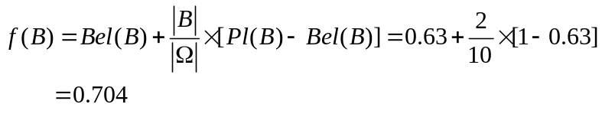Pl(B)=1-Bel(﹁B)=1-0=1
∴ CER(B)=MD(B/E')×f(B)=0.704
(3) 求CER(H)
由r3可得
m1({h1}, {h2}, {h3})={CER(A)×0.2, CER(A)×0.3, CER(A)×0.4}
={0.586×0.2, 0.586×0.3, 0.586×0.4}
={0.117, 0.176, 0.234}
m1(Ω)=1-[m1({h1})+m1({h2})+m1({h3})]=1-[0.117+0.176+0.234]
=0.527
再由r4可得
m2({h1}, {h2}, {h3})={CER(B)×0.3, CER(B)×0.2, CER(B)×0.1}
={0.704×0.3, 0.704×0.2, 0.704×0.1}
={0.211, 0.141, 0.070}
m2(Ω) =1-[m2({h1})+m2({h2})+m2({h3})]=1-[0.211+0.141+0.070]
=0.578
求正交和m=m1m2
K=m1(Ω)×m2(Ω)
+m1({h1})×m2({h1})+m1({h1})×m2(Ω)+m1(Ω)×m2({h1})
+m1({h2})×m2({h2})+m1({h2})×m2(Ω)+m1(Ω)×m2({h2})
+m1({h3})×m2({h3})+m1({h3})×m2(Ω)+m1(Ω)×m2({h3})
=0.527×0.578
+0.117×0.211+0.117×0.578+0.527×0.211
+0.176×0.141+0.176×0.578+0.527×0.141
+0.234×0.070+0.234×0.578+0.527×0.070
=0.305+0.204+0.201+0.189
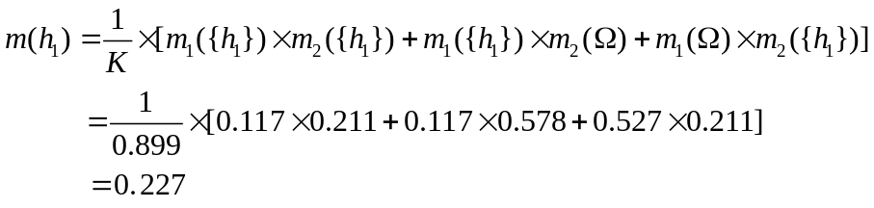 =0.899
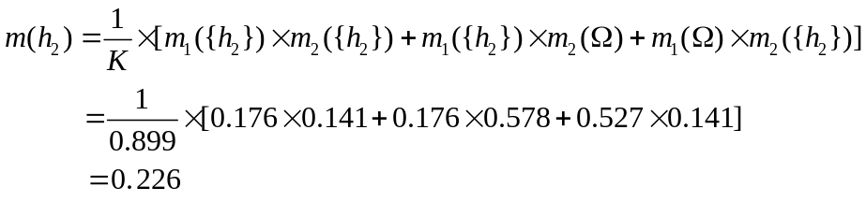同理可得
m(Ω)=1-[m({h1})+m({h2})+m{(h3)}]=1-[0.227+0.226+0.216]
=0.331
再根据m可得
Bel(H)=m({h1})+m({h2})+m({h3})=0.227+0.226+0.216
=0.669
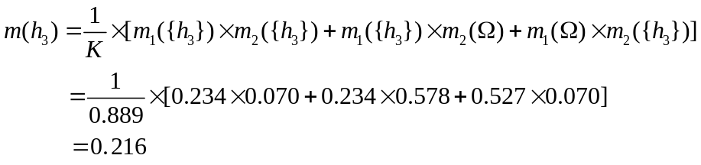
Pl(H)=m(Ω)+Bel(H)=0.331+0.669=1

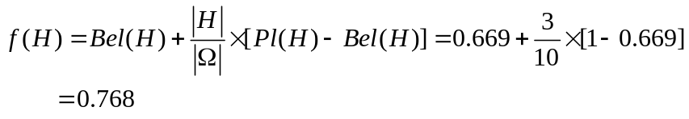CER(H)=MD(H/E')×f(H)=0.768

6.15 设
U=V={1，2，3，4}
且有如下推理规则：
IF x is 少 THEN y is 多
其中，“少”与“多”分别是U与V上的模糊集，设
少=0.9/1+0.7/2+0.4/3
多=0.3/2+0.7/3+0.9/4
已知事实为
x is 较少
“较少”的模糊集为
较少=0.8/1+0.5/2+0.2/3
请用模糊关系Rm求出模糊结论。
解：先用模糊关系Rm求出规则
IF x is 少 THEN y is 多
所包含的模糊关系R_{m}
R_{m} (1,1)=(0.9∧0)∨(1-0.9)=0.1
R_{m} (1,2)=(0.9∧0.3)∨(1-0.9)=0.3
R_{m} (1,3)=(0.9∧0.7)∨(1-0.9)=0.7
R_{m} (1,4)=(0.9∧0.9)∨(1-0.9)=0.7
R_{m} (2,1)=(0.7∧0)∨(1-0.7)=0.3
R_{m} (2,2)=(0.7∧0.3)∨(1-0.7)=0.3
R_{m} (2,3)=(0.7∧0.7)∨(1-0.7)=0.7
R_{m} (2,4)=(0.7∧0.9)∨(1-0.7)=0.7
R_{m} (3,1)=(0.4∧0)∨(1-0.4)=0.6
R_{m} (3,2)=(0.4∧0.3)∨(1-0.4)=0.6
R_{m} (3,3)=(0.4∧0.7)∨(1-0.4)=0.6
R_{m} (3,4)=(0.4∧0.9)∨(1-0.4)=0.6
R_{m} (4,1)=(0∧0)∨(1-0)=1
R_{m} (4,2)=(0∧0.3)∨(1-0)=1
R_{m} (4,3)=(0∧0.7)∨(1-0)=1
R_{m} (3,4)=(0∧0.9)∨(1-0)=1
即：
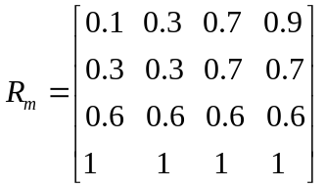
因此有
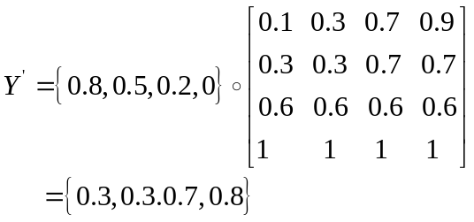
即，模糊结论为
Y’={0.3, 0.3, 0.7, 0.8}

6.16 设
U=V=W={1,2,3,4}
且设有如下规则：
r₁：IF x is F THEN y is G
r₂：IF y is G THEN z is H
r₃：IF x is F THEN z is H
其中，F、G、H的模糊集分别为：
F=1/1+0.8/2+0.5/3+0.4/4
G=0.1/2+0.2/3+0.4/4
H=0.2/2+0.5/3+0.8/4
请分别对各种模糊关系验证满足模糊三段论的情况。
解：本题的解题思路是：
由模糊集F和G求出r₁所表示的模糊关系R_{1m}, R_{1c}, R_{1g}
再由模糊集G和H求出r₂所表示的模糊关系R_{2m}, R_{2c}, R_{2g}
再由模糊集F和H求出r₃所表示的模糊关系R_{3m}, R_{3c}, R_{3g}
然后再将R_{1m}, R_{1c}, R_{1g}分别与R_{2m}, R_{2c}, R_{2g}合成得R_{12 m}, R_{12c}, R_{12g}
最后将R_{12 m}, R_{12c}, R_{12g}分别与R_{3m}, R_{3c}, R_{3g}比较

